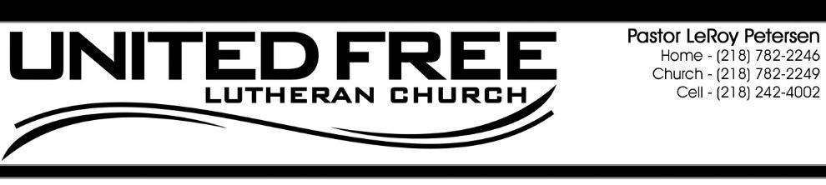
June 7, 2026

First Sunday after Trinity

WELCOME VISITORS: Please sign the guest book in the Narthex.
We will be using pp. 2-5 in the Ambassador Hymnal for our order of worship. If you would like more information about UFLC, visit unitedfreeaflc.com.

CALL TO WORSHIP
OPENING HYMN # 529 “Glory to His Name”
CONFESSION OF SIN
SCRIPTURE LESSONS Jeremiah 9:23-24
Romans 1:1-17
Luke 12:13-21
CONFESSION OF FAITH ~ Apostles’ Creed
OFFERING ~ Free-will
CHILDREN’S MESSAGE

HYMN: # 469 “All the Way My Savior Leads Me”

MESSAGE: Kris Jorgenson “Work is a Good Thing”

HYMN: # 572 “O Love That Wilt Not Let Me Go”

NEWS OF OUR FELLOWSHIP
CONGREGATIONAL AND LORD’S PRAYER p. 5
BENEDICTION & THREE-FOLD AMEN p. 5

CLOSING HYMN #251 “God Be With You Til We Meet Again”

GO IN PEACE AND SERVE THE LORD

What’s Happening This Week?

Sunday, June 7th: 10am Worship Service
9-1pm Pancake Breakfast for Lois Jackson in Badger
3pm Annual Appreciation Day at Galilee Bible Camp-Chos3n

Wednesday, June 10th: WMF Annual Conference in Moorhead

June 10-13th: AFLC Annual Conference in Moorhead

Friday, June 12th: Please join us in celebrating Erika Howell’s Bridal Shower (bride to be of Jacob Bergsnev) from 5-7pm @ Bethel Lutheran Church.
LOOKING AHEAD:

Sunday, June 14th: 10am Worship Service
VBS meeting following the service ~ We are looking for someone to plan and lead crafts, plan and serve snacks and volunteers to help decorate! If you cannot make meeting but would be willing to help, talk to Lynn. Thanks!

June 16-21st: Galilee Teen Camp (kids from UFLC are paid for by UFLC)

Wednesday, June 17th: UFLC is being asked to help cook at Bible camp – Looking to fill shifts for 9:00am-1:00pm and 2:00pm-6:00pm. If you’re willing to help, please contact Angie at 701-317-1095

Sunday, June 21st: 10:45am Camp Sunday Worship Service at Galilee

June 21-25th: Galilee Pre-teen Camp (kids from UFLC are paid for by UFLC)

Note: Shania is putting together a directory. Please send a photo to shaniataylorphotography@gmail.com by June 14th!

Important Summer Dates:
- July 8-11th – Galilee Family Camp
- August 3-7th – VBS with Zion team from the FLBC 9:30am-12pm

June Ushers: Charles Strand, Sawyer Strand, Kendall Anderson
Please send items for the bulletin to Michele by midnight Wednesday.
email unitedfreegreenbush@gmail.com with any bulletin or Circle of Sunshine updates.

